**Daily Scrum or Standup Meeting**

Team name: ___Team 4______________________

Scrum Master: _______Carter Figgins________________

Date:__________10/21/19_____________________

|  |  |  |  |
| --- | --- | --- | --- |
| **Team Member** | **What did you do since the last scrum?** | **What do you plan to do before the next scrum?** | **What obstacles do you have?** |
| Carter Figgins | Built three Pages and connected them to Django | Finish all page working on. Connect pages together in Django | None so far |
| Brock Francom | Researched Django, and started the item view and the Item list view. | Finish the item and list views, with the rest of the pages assigned to me. | Mac doesn’t play nice with Django sometimes. |
| Waseca Hodson | Set up modle.py and designed data base. fields listed and oultlined | Look over database and fix. | none |
| Sterling Tolley | Researched Django | Finish pages I’m working on, draft simple design standards document |  |
|  |  |  |  |

# Burndown

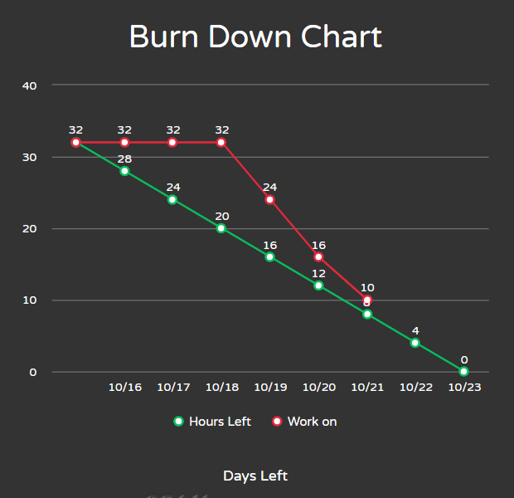

# Screenshot of you project board

